September 15, 2016

The town of Clarksburg began at the crossroad of two Native American trails. Today, there are 20,000 residents and growing.

In 2015, the town Chamber of Commerce held a flag design contest. The winning design is being raised over Clarksburg today.

### Event Committee

The Clarksburg Historical Society, Inc.

www.clarksburgmdhistory.org

### Event Speakers/Performers

Mr. Craig L Rice

Ms. Lynne Kingsley

Ms. Joann Woodson

Ms. Shaneea Peek

Clarksburg HS Band, under the direction of Mr. Chuck Orifici

Ms. Caty House

### Contributors

MNCPPC-Little Bennett Park Staff and special thanks to Ms. Wendy Hanley, Park Manager

The Clarksburg Chamber of Commerce

Clarksburg Elementary School fifth graders and special thanks to Mr. Carl Bencal, Principal

Mr. Patrick Darby,” keeper of the flag”

Clarksburg Town Flag Raising

# Special Thanks

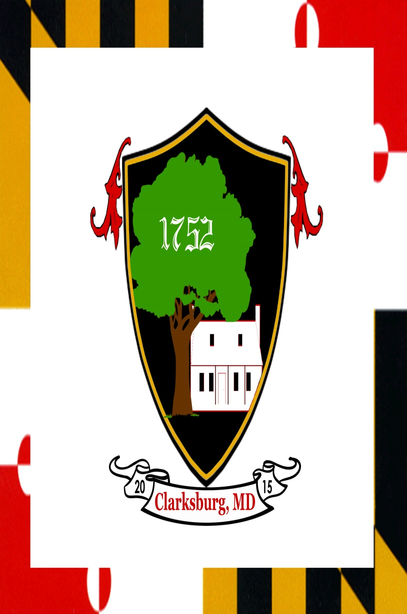

### Introduction

Music: We Gather Together

Welcome: Jean Hulse-Hayman

Music: Excerpt from Stars and Stripes Forever

Pledge of Allegiance: led by the Clarksburg Historical Society

### Speakers

Dowden’s Ordinary : Joann Woodson, President Clarksburg Historical Society, Inc.

Clarksburg Chamber of Commerce: Lynne Kingsley, Vice President

Our town flag: Shaneea Peek, designer

Clarksburg Looking Forward: Craig Rice, District 2 Representative of Montgomery County Council

### Flag Raising and Closing Song

Music: You’re a Grand Old Flag/Yankee Doodle

America the Beautiful:

Caty House

Clarksburg is a town that began at the crossroads of two Native American trails. The crossroads were a natural place for hunters and settlers to exchange goods. Lots of human activity in the area led to the establishment of a trading post. Consequently the trading post led to the application for a land grant to establish an ordinary here and so what we now call Clarksburg began officially in 1752. It wasn’t until the 1780’s when a post office was opened that our town finally got its name. There is so much more to know about Clarksburg’s rich history, however history is being made today as we raise our town flag for the first time near the original crossroads that started it all.

# Program

## History is being made